

**ARABICA VIET NAM TECHNOLOGY APPLICATION JOINT STOCK COMPANY**

**USER MANUAL**

**Voicemail content management system**

**Hà Nội, 08/2021**

**CHANGE LEADERBOARD**

*A – Create New, M – Modify, D – Delete

|  |  |  |  |  |  |  |
| --- | --- | --- | --- | --- | --- | --- |
| **Day**  **change** | **Location**  **change** | **A*, M, D** | **Origin** | **Session**  **old version** | **Description of**  **changes** | **Session**  **new version** |
| 29/08/2021 | Entire | A |  |  | Create a new document | 1.0 |

TABLE OF CONTENTS

PART 1: Introduction 4

1.1 Document purpose 4

PART 2: Voicemail content management software user manual 5

2.1 Login 5

2.2 Log out 6

2.3 Traffic report 6

2.4 Subscriber report 7

2.5 Call histories 8

2.6 Emergency Voice Message 9

2.7 Call to Short Code 10

2.8 On/Off Packages 11

2.9 SMS Histories 12

2.10 SMS Notification 13

# PART 1: Introduction

## Document purpose

**General purpose**

* This document is built for detailed manual work manipulating Voicemail management system functions
* The content presented in the document is concise, in the order of functions and instructions for the implementation step by step. So users can easily use the program through this document
* This document is provided to the User Guide for Software version 1.0

**Scope of use**

* This document applies to the Voicemail content management system
* This document serves the following audiences: System administrators and individuals using the system.

**Document description**

* Part 1: Introduction.
* Part 2: Voicemail content management software user manual.

# PART 2: Voicemail content management software user manual

## Login

Purpose: Log in to the system to use the system

Steps to log in to the system:

* Step 1: Access to provided link to the system.
* Step 2: Enter the information including: username, password and click **Login.**

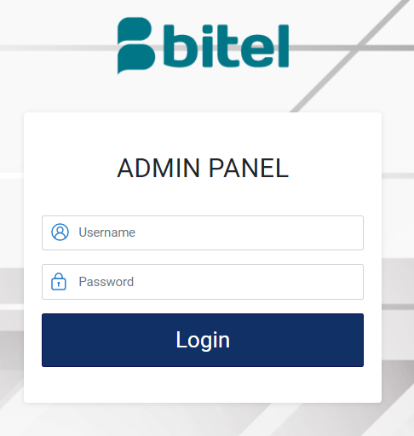

## Log out

Purpose: To enhance information security when not using the software, users should log out of the software.

* To log out of the system, the user clicks on **Logout** from sidebar. If you can’t find the menu, click on caret icon to open the menu.

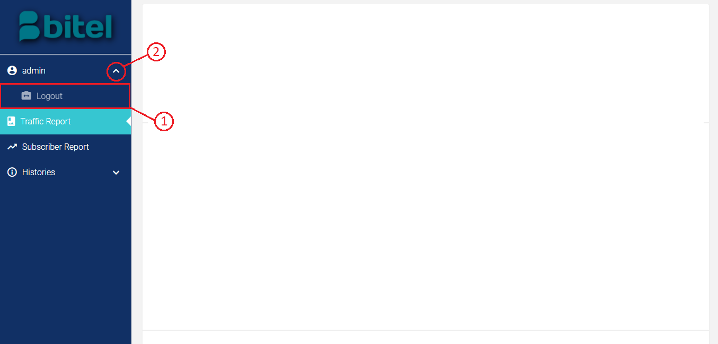

## Traffic report

Purpose: Allows user follow traffic on the system.

Steps to follow:

* Step 1: Successfully log in to the system with the provided account, click on **Traffic Report** from sidebar.

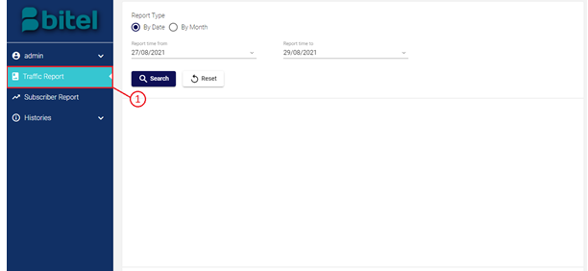

* Step 2: Select a date range , and click on **Search** button to get the report.

The system traffic will be shown as charts below.

Click on **Reset** button will set date range to original state.

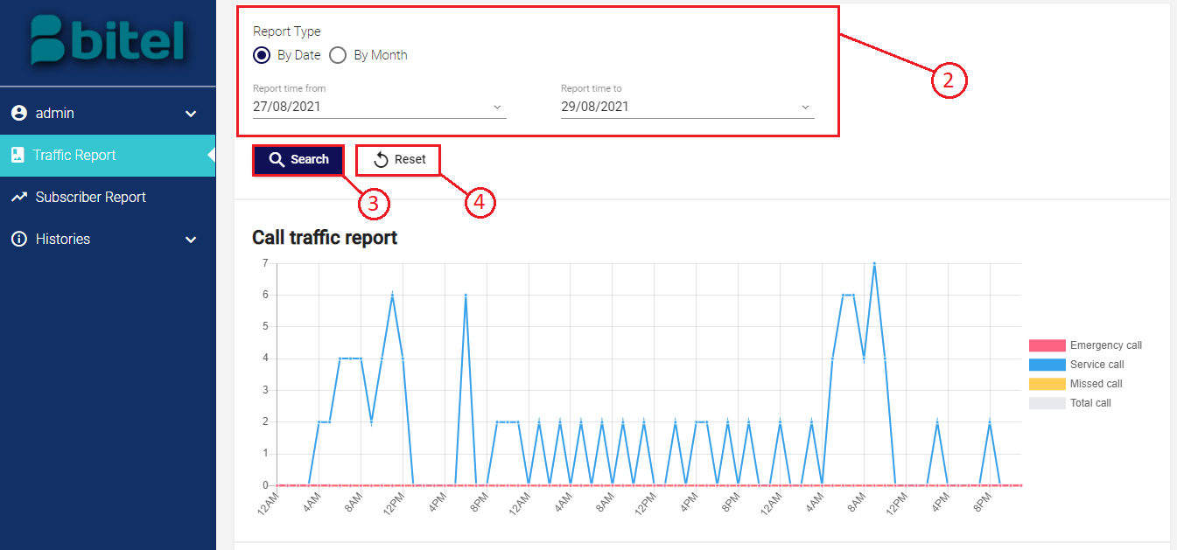

## Subscriber report

Purpose: Allows user follow subscribers on the system.

Steps to follow:

* Step 1: Successfully log in to the system with the provided account, click on **Subscriber Report** from sidebar.

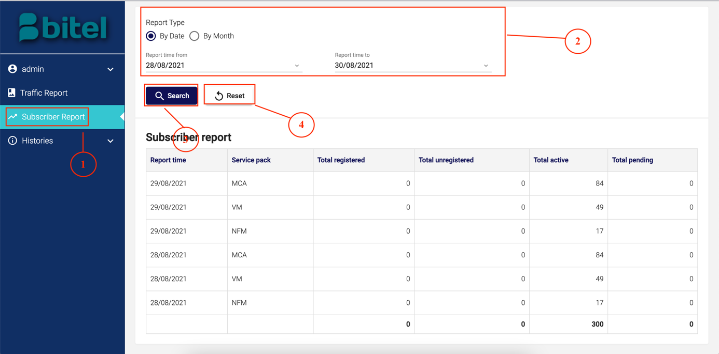

* Step 2: Select a date range , and click on **Search** button to get the report.

The reports on subscribers will be shown below.

Click on **Reset** button will set date range to original state.



|  |  |  |
| --- | --- | --- |
| **Column name** | **Data type** | **Description** |
| Report time | Date | The time when the reports are recorded in the system. |
| Service pack | Text | Service pack name which is recorded. |
| Total registered | Number | Total number of times the service pack was registered. |
| Total unregistered | Number | Total number of times the service pack was unregistered. |
| Total active | Number | Total number of active service packs. |
| Total pending | Number | Total number of pending service packs. |

## Call histories

Purpose: Allows user follow call histories of subscribers on the system.

Steps to follow:

* Step 1: Successfully log in to the system with the provided account, open **Histories** menu from sidebar and click on **Call Histories** .

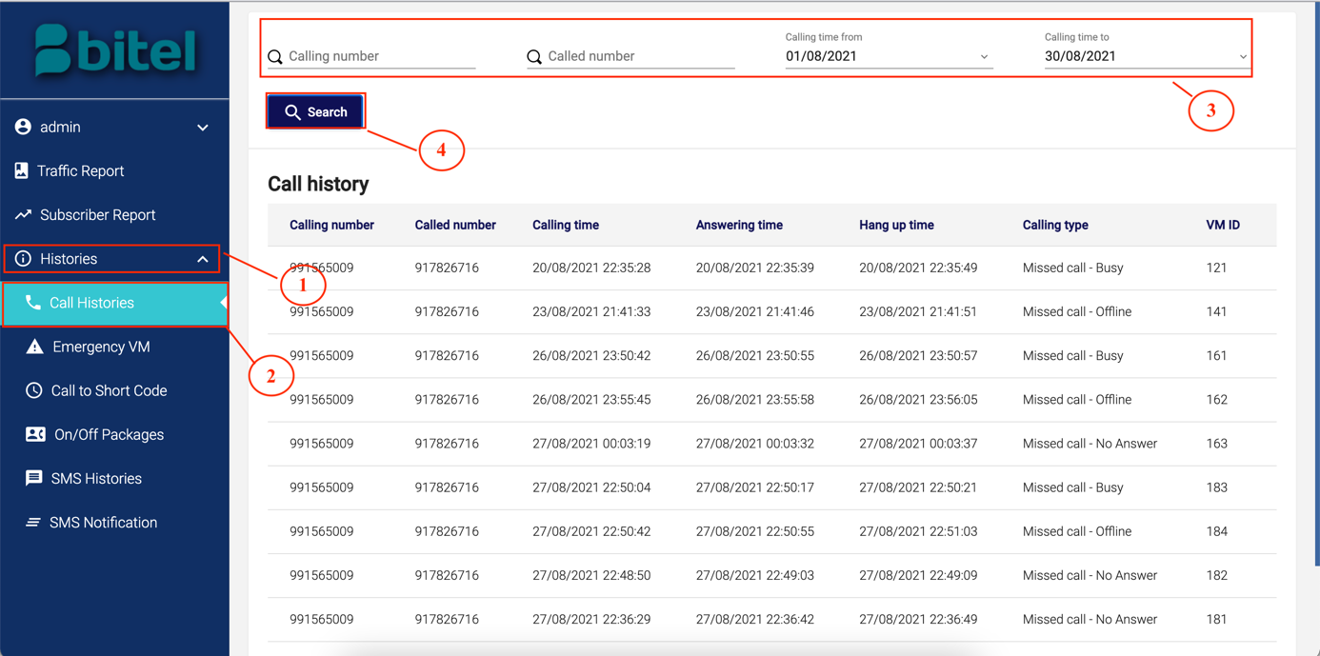

* Step 2: Input search information and date range , and click on **Search** button to get the information.

Call histories on system will be shown below.



|  |  |  |
| --- | --- | --- |
| **Column name** | **Data type** | **Description** |
| Calling number | Text | Number of subscriber making the call. |
| Called number | Text | Number of subscriber receiving the call. |
| Calling time | Time | The time the call started to be made, caller connected. |
| Answering time | Time | The time the receiver answered the call, and caller and receiver are connected. |
| Hang up time | Time | The time the call ended. |
| Calling type | Text | How calls are classified   * Service call * Missed call |
| VM ID | Number | ID of recorded voice message (if exist). |

## Emergency Voice Message

Purpose: Allows user follow emergency voice mails on the system.

Steps to follow:

* Step 1: Successfully log in to the system with the provided account, open **Histories** menu from sidebar and click on **Emergency VM** .

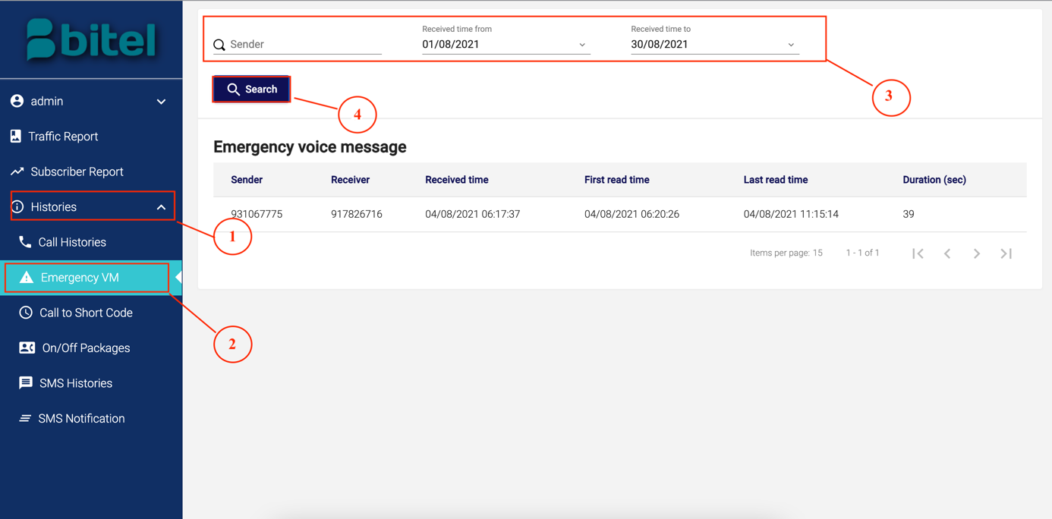

* Step 2: Input search information and date range , and click on **Search** button to get the information.

Emergency voice messages on system will be shown below.



|  |  |  |
| --- | --- | --- |
| **Column name** | **Data type** | **Description** |
| Sender | Text | Number of subscriber sending voice message. |
| Receiver | Text | Number of subscriber receiving voice message. |
| Received time | Time | The time the receiver is notified about voice message. |
| First read time | Time | The time the receiver first open voice message. |
| Last read time | Time | The time the receiver last open voice message. |
| Duration | Time (second) | How long the voice message is recorded in second. |

## Call to Short Code

Purpose: Allows user follow calls to short code of the system.

Steps to follow:

* Step 1: Successfully log in to the system with the provided account, open **Histories** menu from sidebar and click on **Call to Short Code**.

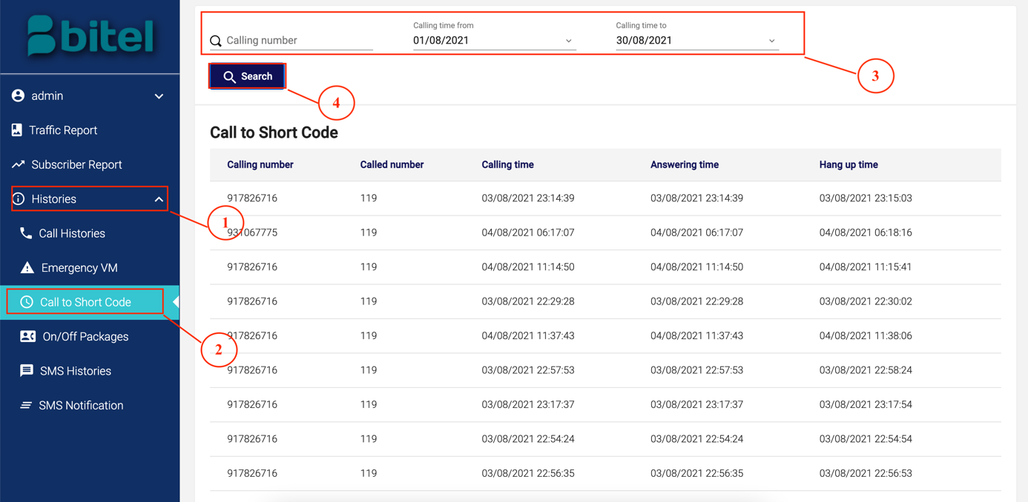

* Step 2: Input search information and date range , and click on **Search** button to get the information.

Calls to short code on system will be shown below.



|  |  |  |
| --- | --- | --- |
| **Column name** | **Data type** | **Description** |
| Calling number | Text | Number of subscriber calling to system. |
| Called number | Text | Service number receiving the call. |
| Calling time | Time | The time the call started to be made, caller connected. |
| Answering time | Time | The time the call is answered. |
| Hang up time | Time | The time the call ended. |

## On/Off Packages

Purpose: Allows user follow service packages of subscribers on the system.

Steps to follow:

* Step 1: Successfully log in to the system with the provided account, open **Histories** menu from sidebar and click on **On/Off Packages** .

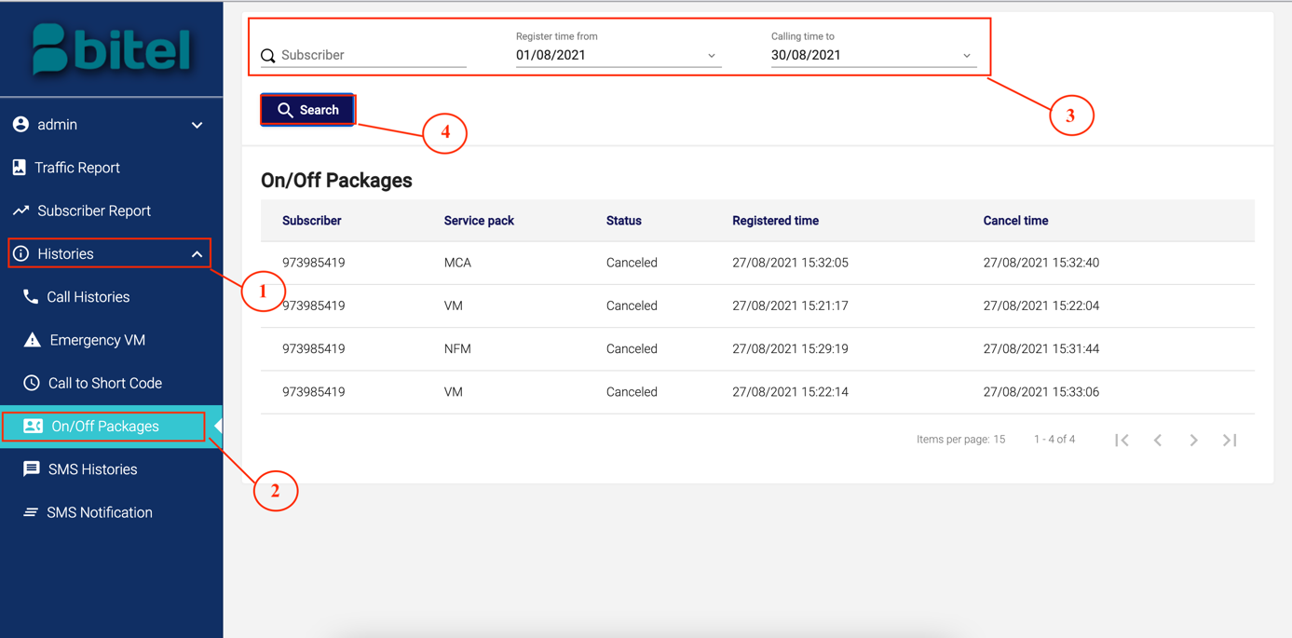

* Step 2: Input search information and date range , and click on **Search** button to get the information.

Service packages status on system will be shown below.



|  |  |  |
| --- | --- | --- |
| **Column name** | **Data type** | **Description** |
| Subscriber | Text | Number of subscriber active/cancel service packages. |
| Service pack | Text | Name of service pack to be activated or canceled. |
| Status | Text | The updated status of service pack. |
| Registered time | Time | The time the service pack was last registered. |
| Cancel time | Time | The time the service pack was last canceled. |

## SMS Histories

Purpose: Allows user follow SMS histories of subscribers on the system.

Steps to follow:

* Step 1: Successfully log in to the system with the provided account, open **Histories** menu from sidebar and click on **SMS Histories** .

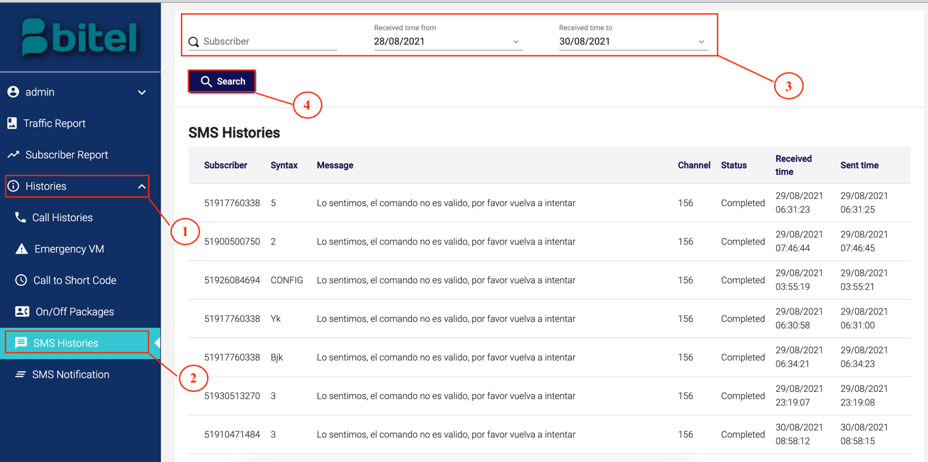

* Step 2: Input search information and date range , and click on **Search** button to get the information.

SMS histories on system will be shown below.



|  |  |  |
| --- | --- | --- |
| **Column name** | **Data type** | **Description** |
| Subscriber | Text | Number of subscriber sending the message. |
| Syntax | Text | The message syntax has been sent. |
| Message | Text | The message body has been sent. |
| Channel | Number | The channel in which the message has been sent. |
| Status | Text | The status of the message   * Sending completed * Sending failed |
| Received time | Time | The time the message was received. |
| Sent time | Time | The time the message was sent. |

## SMS Notification

Purpose: Allows user follow SMS notifications on the system.

Steps to follow:

* Step 1: Successfully log in to the system with the provided account, open **Histories** menu from sidebar and click on **SMS Notification** .

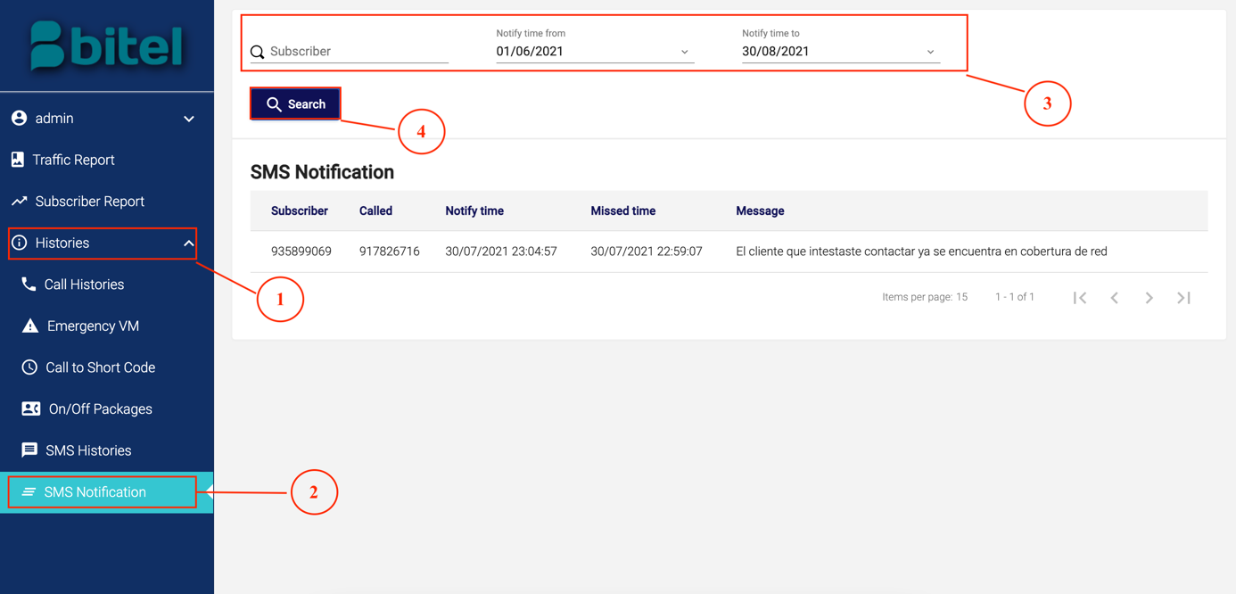

* Step 2: Input search information and date range , and click on **Search** button to get the information.

SMS notifications on system will be shown below.



|  |  |  |
| --- | --- | --- |
| **Column name** | **Data type** | **Description** |
| Subscriber | Text | Number of subscriber sending the notification. |
| Called | Text | Number of subscriber receiving the notification. |
| Notify time | Time | The time the receiver reconnected and notification was received. |
| Missed time | Time | The time the call was missed. |
| Message | Text | The message body of notification. |